Legal Addresses of Rockwood Brown Deed Purchases (and Sales) in Yellowstone County

March 13, 1913 Purchase of two properties

Quarter Section Information for GeoLocate: W2NE4 & E2NW4
Correct Format for GeoLocate: T2S R21E Sec. 28
Correct Coordinate Format for GoogleEarth: 45.633511 -109.140316
and
Correct Coordinate Format for GoogleEarth: 45.633451 -109.145594

Scanned: February 28, 1913 "Warranty Deed" $1.00
(See print-out for legal description)

APRIL 8, 1916
Quarter Section Information for GeoLocate: NE4
Correct Format for GeoLocate: T2N R25E Sec. 32
Correct Format for GoogleEarth: 45.881533 -108.647145

Scanned: October 23, 1916 Deed Record No. 57 Purchase $15,000:
(See print-out for legal description)

Scanned: December 17, 1916 "Warranty Deed Record No. 56 $1.00
(See print-out for legal description)

January 16, 1917
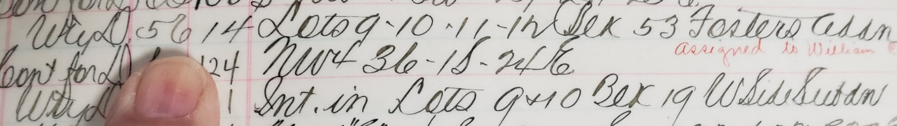
Lots 9,10,11 in Blk 53 Fosters Addn
Now part of 402 N. Broadway, Billings MT 59101 – Stockman’s Bank downtown location

March 2, 1917:
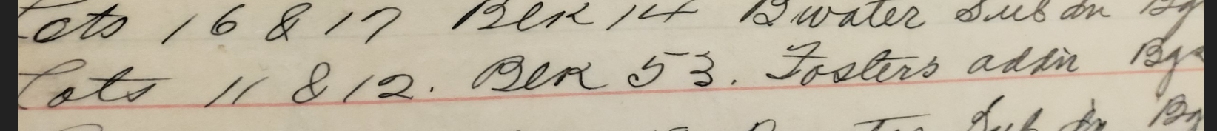
Lots 16 & 17 Blk 14 Bwater (Broadwater) Subdiv Bgs (Billings)
Lots 11 & 12 Blk 53 Fosters addn Bgs (Billings) Now part of 402 N. Broadway, Billings MT 59101 – Stockman’s Bank downtown location

Scanned: March 5, 1917 $1.00 Warranty Deed Record No. 60
(See print-out for legal description)

March 13, 1917
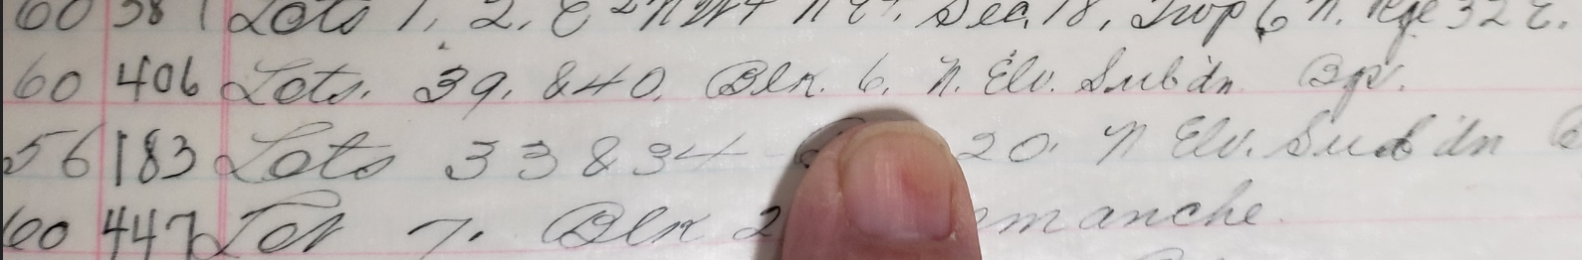
Lots 39 & 40 Blk 6 N. Elv (Elevation) Subdv Bgs (Billings)
1119 N. 31st St, Billings, MT 59101 – Rockwood & Elizabeth Brown home

Scanned: March 19, 1917 Warranty Deed No. 56 Between Nellie Brown (Mother) and Rockwood Brown (son)$1.00 (See print-out for legal description)

Scanned: April 26, 1917 7,868 Acres for $11,803.00 Deed Record 61
(See print-out for legal description)

June 26, 1917
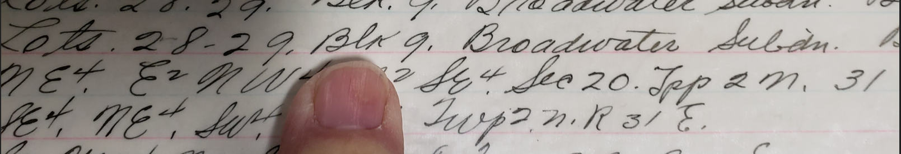
Lots 28-29 Blk 9 Broadwater Subdv Bgs (Billings)
Now part of 836 and 838 Terry Avenue, Billings MT 59101

March 30, 1918:
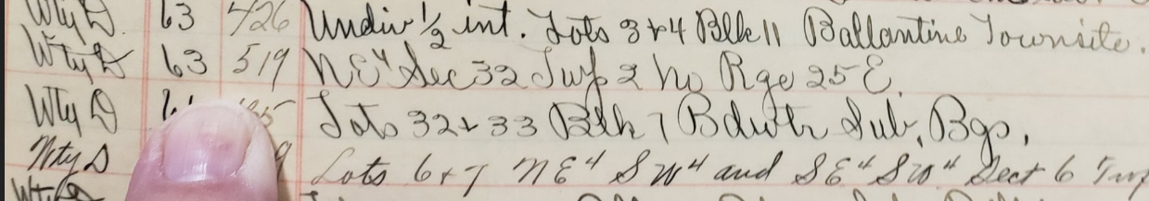

Quarter Section Information for GeoLocate: NE4
Correct Format for GeoLocate: T2N R25E Sec. 32
Correct Coordinate Format for GoogleEarth: 45.878187 -108.642253

November 19, 1918
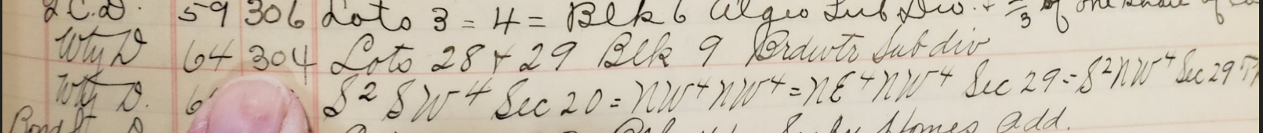
Lots 28 & 29 Blk 9 Brdwtr (Broadwater) Subdiv
Now part of 836 and 838 Terry Avenue, Billings MT 59101

November 20, 1922:
Lots 39 & 40 Blk 6 No Elev (Elevation) Subdiv Bgs (Billings)
1119 N. 31st St, Billings, MT 59101 – Rockwood & Elizabeth Brown home

Scanned: January 30, 1922 Sheriff Sale $3994.00 Deed Record No. 80

Quarter Section Information for GeoLocate: N2NW4
Correct Format for GeoLocate: T1N R25E Sec. 32
Correct Coordinate Format for GoogleEarth: 45.796642 -108.647127

June 23, 1922:

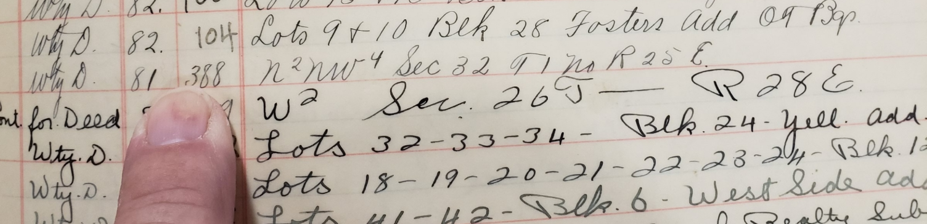

Quarter Section Information for GeoLocate: N2NW4
Correct Format for GeoLocate: T1N R25E Sec.32
Correct Coordinate Format for GoogleEarth: 45.796642 -108.647127

November 30, 1922:
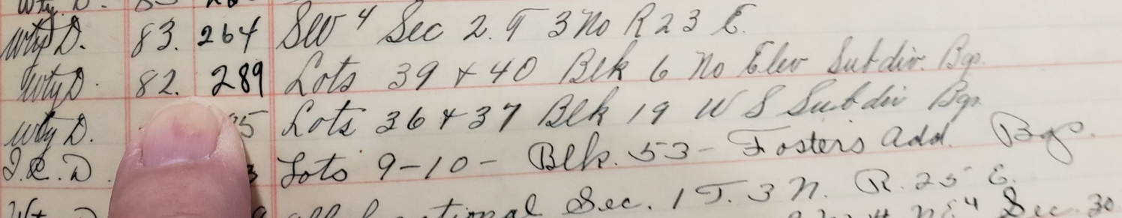
Lots 39 & 40 Blk 6 North Elev (Elevation) Subdiv Bgs (Billings)
1119 N. 31st St, Billings, MT 59101 – Rockwood & Elizabeth Brown home

Scanned: February 20, 1923:
Lots 9,10,11 in Blk 53 Fosters Addn
Now part of 402 N. Broadway, Billings MT 59101 – Stockman’s Bank downtown location

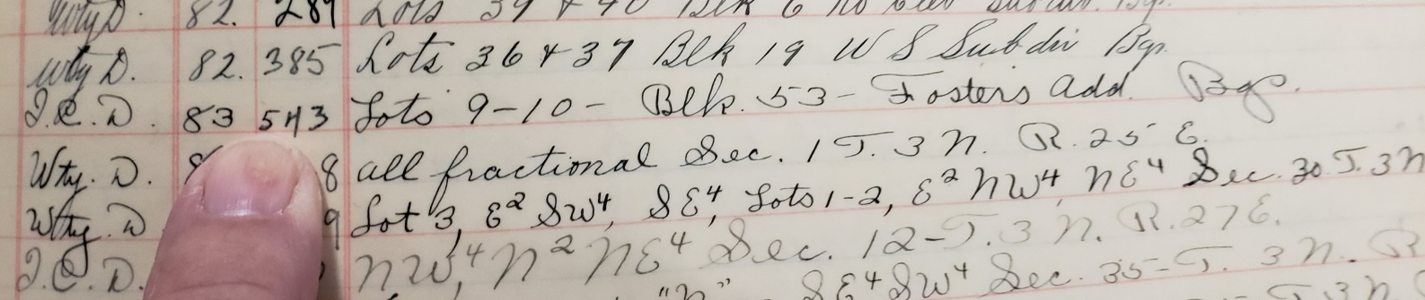
Lots 9,10 in Blk 53 Fosters Addn
Now part of 402 N. Broadway, Billings MT 59101 – Stockman’s Bank downtown location

May 9, 1923:
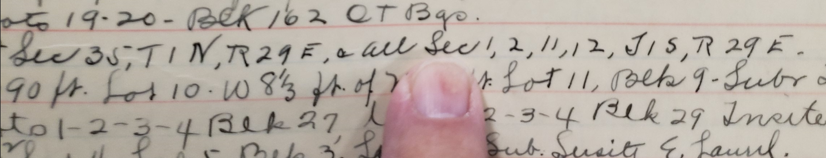

Quarter Section Information for GeoLocate:
Correct Format for GeoLocate: T1N R29E Sec.35
Correct Coordinate Format for GoogleEarth: 45.790762 -108.07861
And
Correct Format for GeoLocate: T1S R29E Sec.1,2,11,12
Correct Coordinate Format for GoogleEarth:
45.774283 -108.079914
45.77429 -108.100663
45.757785 -108.100683
45.75779 -108.079939

September 21, 1925 Deed Record 119
Lots 7 & 8 Blk 55 Orig T (Town) Bgs (Billings)
Part of AT&T building 3000 2nd Ave N Billings MT

June 4, or 8, 1926: Sheriff's Sale "Deed Record 124" $3965.00
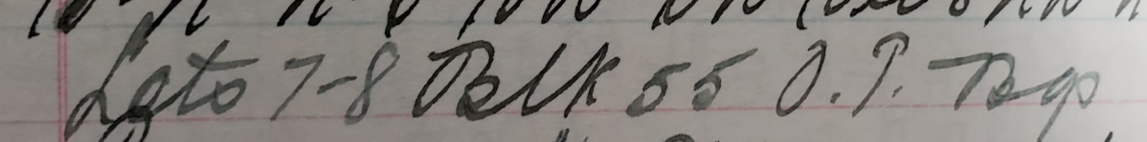
Lots 7-8 Blk 55 Original Town Bgs (Billings)
Part of AT&T building 3000 2nd Ave N Billings MT

Scanned: October ?, 192? Warranty Deed 82 (Can't read)
"Warranty Deed" (See print-out for legal description)

No Legible Date:
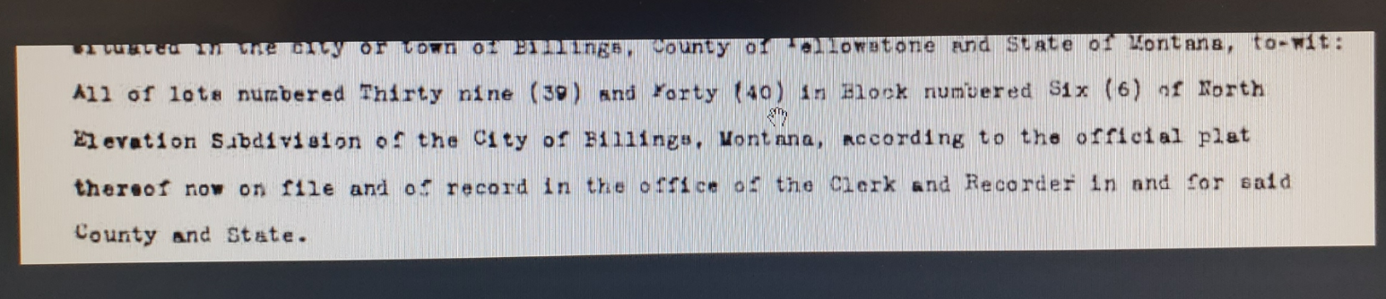
Lots 39 & 40 Blk 6 N. Elv (Elevation) Subdv Bgs (Billings)
1119 N. 31st St, Billings, MT 59101 – Rockwood & Elizabeth Brown home

No Legible date:
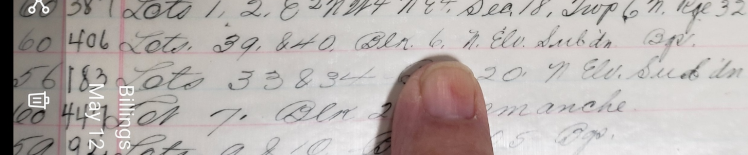
Lots 39 & 40 Blk 6 N. Elv (Elevation) Subdv Bgs (Billings)
1119 N. 31st St, Billings, MT 59101 – Rockwood & Elizabeth Brown home

